Experiment 10

Student Name: Harshit Kumawat  UID: 24BAI70025  Branch: CSE - AIML  Section/Group: 24AIT_KRG G1 | Semester: 4  Date of Performance: 24/4/26  Subject Name: DBMS  Subject Code: 24CSH-298

Aim
To design a trigger that automatically implements the functionality of a primary key, ensuring unique identification of records without manual intervention.
Software Requirements
- Database Management System:
o Oracle Database Express Edition (Oracle XE)
o PostgreSQL Database
- Database Administration Tool / Client Tool:
o Oracle SQL Developer (for Oracle XE)
o pgAdmin (for PostgreSQL)
Objectives
- To create a database trigger that automatically enforces primary key constraints or generates unique key values, replicating the functionality of a stored procedure.
Problem Statement
- In enterprise databases, primary keys must be unique for every record. Manual assignment of keys can lead to errors.
Design a trigger that:
- Automatically generates or enforces a primary key value during record insertion.
- Implements the logic similar to a stored procedure.
- Demonstrates automated primary key functionality for a table.
(Industry relevance: Amazon, Flipkart, Oracle)
Practical/Experiment Steps
- Table Setup: Created the target table (orders) without a default primary key generator to simulate the manual key assignment problem.
- Sequence Creation: Defined an Oracle sequence (order_seq) to serve as the reliable counter for unique numeric IDs.
- Trigger Design: Designed a BEFORE INSERT trigger (trg_order_pk) on the orders table to intercept each insertion event.
- Auto-Key Assignment: Implemented logic inside the trigger to fetch the next value from the sequence and assign it to :NEW.order_id, overriding any user-supplied or NULL value.
- Insertion Testing: Executed multiple INSERT statements without specifying an order_id, relying entirely on the trigger for key generation.
- Output Verification: Queried the orders table after all insertions to confirm unique, sequential primary key values were assigned automatically.
Procedure
- Connected to Oracle/PostgreSQL environment and enabled DBMS output console.
- Created the orders table with order_id as the primary key column (no DEFAULT or auto-increment).
- Created a sequence order_seq starting from 1 with an increment of 1.
- Wrote and compiled the BEFORE INSERT trigger trg_order_pk to populate :NEW.order_id using order_seq.NEXTVAL.
- Inserted multiple rows into orders without specifying order_id.
- Verified that all rows received unique, auto-generated primary key values by running a SELECT query.
Input/Output Analysis
SQL Input Queries
CREATE TABLE orders (
order_id NUMBER PRIMARY KEY,
item_name VARCHAR2(100),
quantity NUMBER,
order_date DATE
);
Output
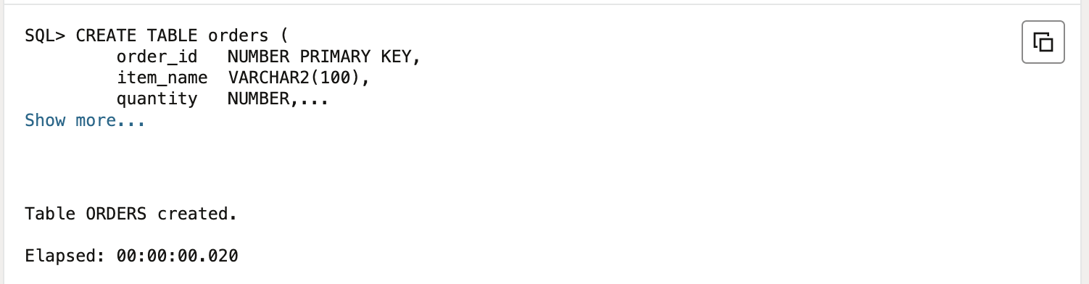
SQL Input Queries
CREATE SEQUENCE order_seq
START WITH 1
INCREMENT BY 1
NOCACHE
NOCYCLE;
Output
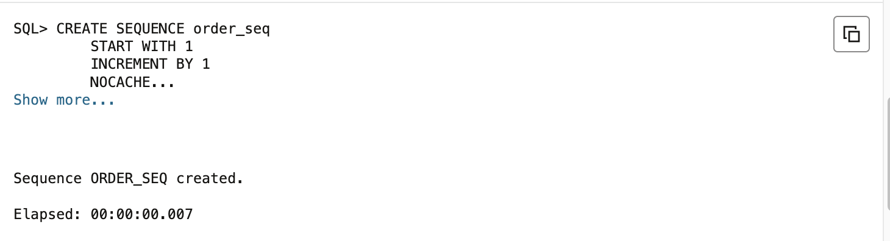
SQL Input Queries
CREATE OR REPLACE TRIGGER trg_order_pk
BEFORE INSERT ON orders
FOR EACH ROW
BEGIN
IF :NEW.order_id IS NULL THEN
:NEW.order_id := order_seq.NEXTVAL;
END IF;
END;
/
Output
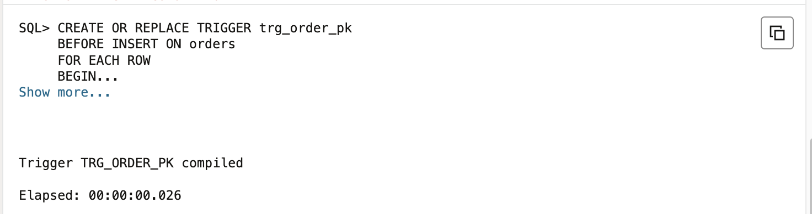
SQL Input Queries
INSERT INTO orders (item_name, quantity, order_date)
VALUES ('Laptop', 2, SYSDATE);

INSERT INTO orders (item_name, quantity, order_date)
VALUES ('Mobile', 5, SYSDATE);

INSERT INTO orders (item_name, quantity, order_date)
VALUES ('Tablet', 3, SYSDATE);

COMMIT;
Output
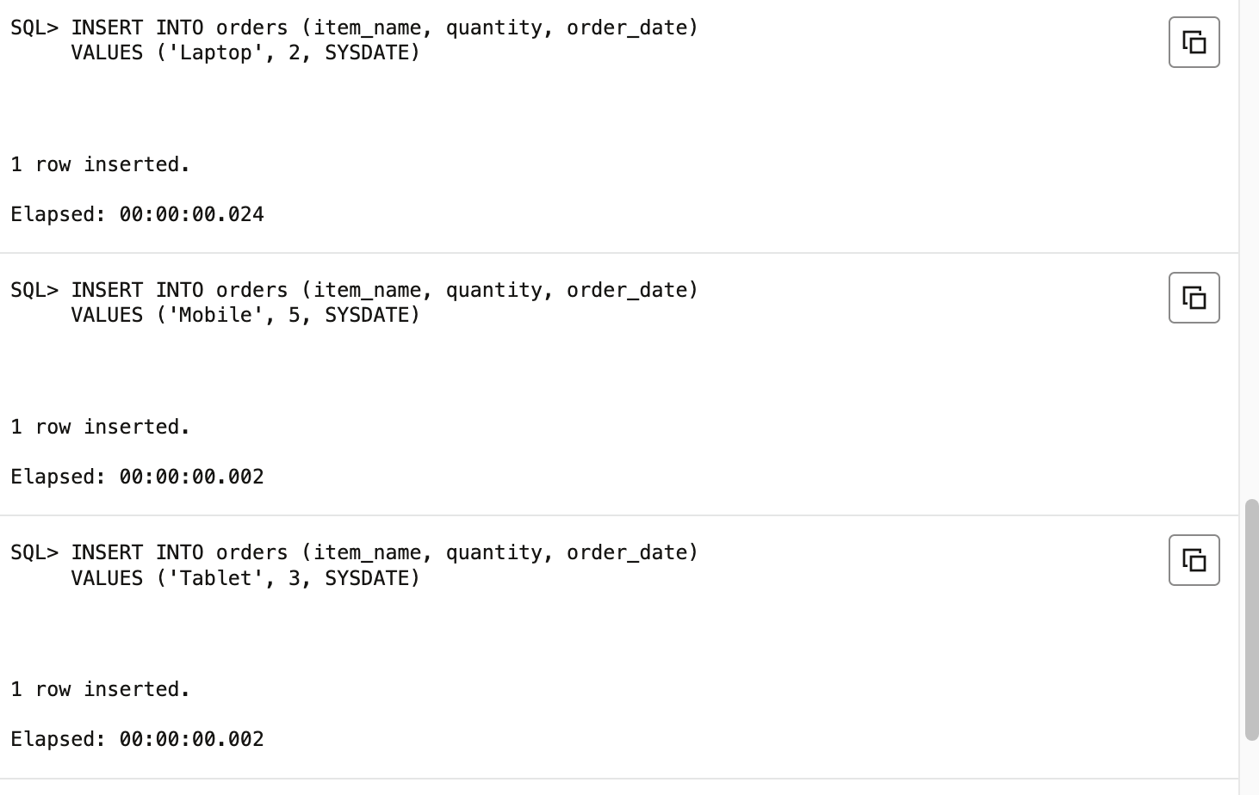
SQL Input Queries
SELECT order_id, item_name, quantity, order_date FROM orders;
Output
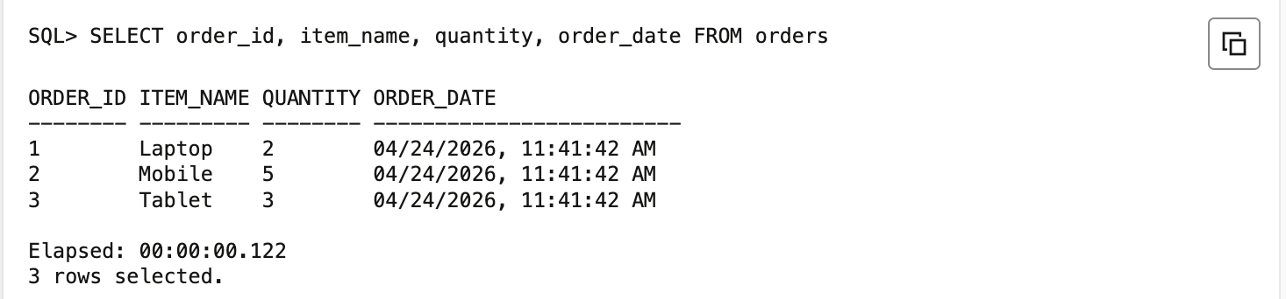
Learning Outcomes
- Trigger Purpose and Working: Understood the purpose and event-driven nature of database triggers, including BEFORE INSERT, AFTER INSERT, and other trigger types.
- Automated Primary Key Functionality: Learned to implement automated primary key generation using triggers combined with sequences, eliminating manual key management.
- Data Integrity Enforcement: Gained expertise in ensuring data integrity automatically without relying on application-level logic or manual key assignment.
- Encapsulation and Security: Applied trigger-based automation relevant to real-world enterprise applications such as Amazon order management, Flipkart inventory systems, and Oracle ERP solutions.

